**Software Requirements**

**Specification**

**For**

**GROCETERIA**

**GROCERY E-COMMERCE**

**Submitted By -**

**Group No. 21**

**ABHISEK PANDA (220950120005)**

**ANKIT AGRAWAL (220950120026)**

**JYOTI VERMA (220950120085)**

**MONALISA SWAIN (220950120102)**

**SAMEEKSHA JAIN (220950120159)**

**CDAC, Bengaluru**

**INDEX**

**Table of Contents**

1. Introduction
   1. Purpose
   2. Product Scope
   3. References

1. Overall Description
   1. Objective
2. External Interfaces
   1. User Interfaces GUI and Help Issues
   2. Security Issues
3. Requirements
   1. Initial non-functional requirements
   2. Functional requirement specifications
4. List of Functions
   1. Functional Description
5. Designing Documentation
   1. Use case Diagram
   2. E-R Diagram

1. Introduction

**1.1 Purpose**

The main purpose of this grocery management system is to serve customer to book/purchase grocery products online. It allows customers to do online shopping of grocery products. It helps in searching products category-wise. (Like vegetables, grocery items etc).

It will also in pre-booking of the products by the pay-later option available on the website.

It will also allow customers to avail different exciting offers.

**1.2 Product Scope**

The project has a wide scope as it is not intended to a particular organization. Moreover, it will provide facility to its customers 24x7. This system will reduce the manual operation required to maintain all the records of grocery items.

**1.3 References**

➢ IEEE. IEEE Std 830-1998 IEEE Recommended Practice for Software Requirements Specifications. IEEE Computer Society, 1998.

2. Overall Description

**2.1 Objective**

The “Grocery management system” has been developed to override the problems prevailing in practising manual system.

It will lead to error-free, secure, reliable and fast management system. It will assist user to concentrate on their other activities rather than concentrating on big grocery list monthly.

The use can easily Register himself by providing few details and can login with the username and password. After logging to the website, he/she can look on to the listed items and can add to their cart depending on their requirements which then can be ordered later by paying for it either online or by home-delivery options. Here the customers can delete and add items easily from the cart with the provided options as – add item – delete item.

3. External Interfaces

**3.1 User Interfaces GUI and Help Issues:**

These screens will be user friendly and help will be available at all levels. Help can be any type like site map and also online help, help for entering the standard codes i.e., List of Values will be provided wherever possible in order to reduce data entry errors. User has to select the proper value from list wherever provided e.g.: Picking the date from the given list.

**3.2 Security Issues:**

User at different levels in the hierarchy will have restricted access to information. Only authorized users will be able to access the confidential information. Only the System Administrator will do system administration and maintenance work. And update the information. Various security mechanisms will be provided such as password. e.g. –

Password protection for valid user.

(Provided by RDBMS) -Password at application level.

4. Requirements

**4.1 Initial non-functional requirements**

* Secure access of confidential data (user’s details). SSL can be used.
* 24 X 7 availability.
* Better component design to get better performance at peak time
* Advertisement space where it will effectively catch the customer’s attention and as a source of revenue.
* In addition to the above-mentioned points, due to the highly evolving nature of the project, the following are planned to be delivered if deemed necessary.
* More payment gateways.
* Dynamic price model by which prices can be changed based on demand and supply
* Dynamic Storefront: Each customer will have a web page personalized based on his or her recent purchases. This is the equivalent of having a unique storefront for each customer in hopes of drawing in as many return customers as possible.

**4.2 Functional requirements specifications**

* **Product Admin: -**

It includes the information of the products, item no, size, categories etc. it’s is also the admin of vendor or seller where they can put the information of the products in websites.

* **Transaction: -**

Transaction is a payment method in which the transfer of money of buying products. This process is secure and password protected. Three steps involved in the online transaction are Registration, Placing an order, and, Payment.

* **Reporting: -**

After ordering for the product, the system will send one copy of the bill to the customer’s Email-address and another one for the system data base.

* **Stock Report: -**

Produce the quantity of the products available and status of the products.

* **Delivery Report: -**

List of the products that can be delivered to the customer.

* **Registration: -**

Customer wants to buy the product then he/she must be registered, unregistered user can’t go to the shopping cart.

* **Login: -**

Customer logins to the system by entering valid user id and password for the shopping.

* **Changes to Cart**: -

Changes to cart means the customer after login or registration can make order or cancel order of the product from the shopping cart.

* **Payment: -**

In this system we are dealing the mode of payment by Cash. We will extend this to credit card, debit card etc. in the future.

* **Logout: -**

After ordering or surfing for the product customer has to log out.

**5. List of Functions**

|  |  |  |
| --- | --- | --- |
| Sr. No. | Function ID | Name of Function |
| 1. | F-1 | Users order items. |
| 2. | F-2 | User pays for the item. |
| 3. | F-3 | Users list items to be sold. |
| 4. | F-4 | Admin checks and maintains the inventory. |
| 5. | F-5 | Items are delivered to user’s place. |

**5.1 Functional Description:**

**F-1. Function:** **Placing order to the restaurants**.

**Function ID:** F-1

**Purpose:** Items are to be provided to the customer as per their order

Data Entities: Database of the application contain the items based on category.

Frequency: On every order.

**F-2. Function: User pays for the item.**

**Function ID:** F-2

**Purpose:** Payment of the ordered item to be received. Making the payment secure and

hassle-free.

Data Entities: Online or COD.

Frequency: On every order.

**F-3. Function: Users list item to be sold.**

**Function ID:** F-3

**Purpose:** Users can also use the platform to sell their own products which should be verified

by the admin.

Organization Unit: Assigned Admin.

Frequency: Daily.

**F-4. Function: Admin checks and maintains the Inventory**

**Function ID:** F-4

**Purpose:** Admin assigned for different categories should keep check on items about to go out of stock, so that re-stocking could be done for uninterrupted service.

Organization Unit: Assigned Admin.

Data Entities: Keeps data of most ordered and least ordered items.

Frequency: Daily.

**F-5. Function: Items are delivered to user’s place.**

**Function ID:** F-5

**Purpose:** User should get the ordered item within the specified duration of time to prevent inconvenience.

Organization Unit: Delivery Manager.

Data Entities: Feedback given by customer.

Frequency: Every delivery.

6. Designing Documentation

**6.1 Use case Diagram**

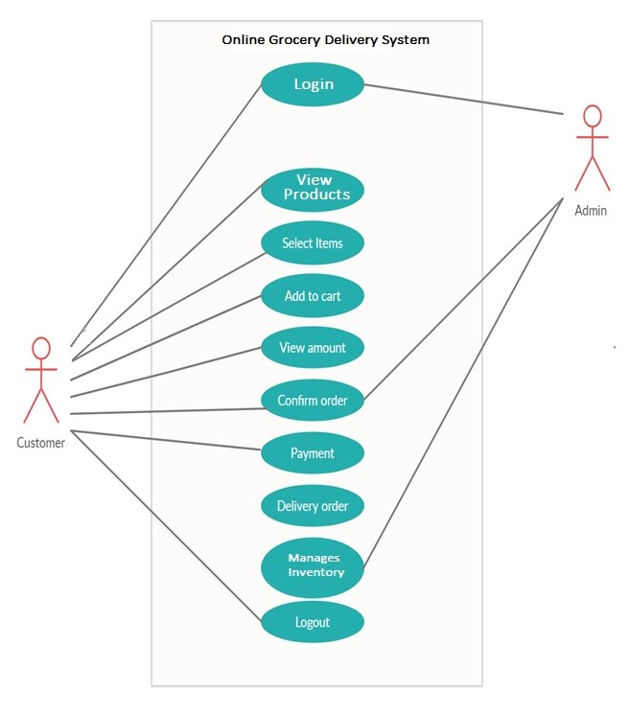

**6.2 ER Diagram**

